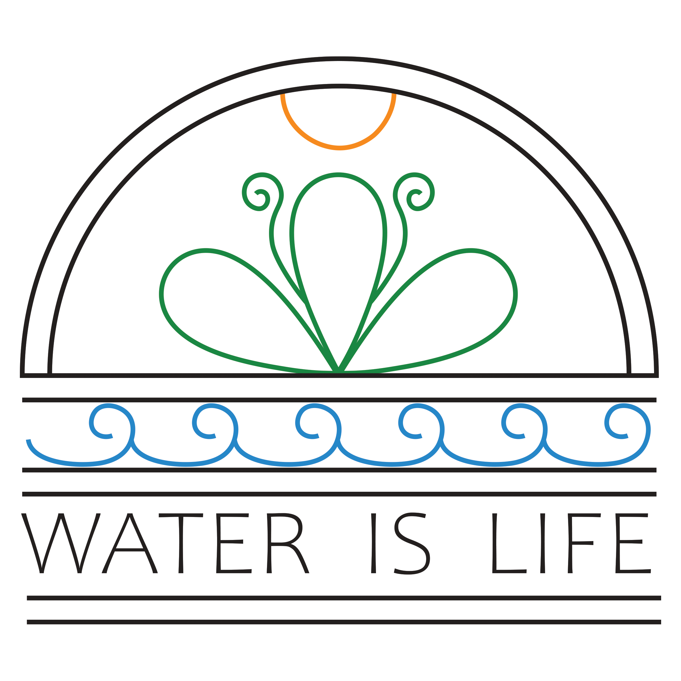
Oneida Nation
Water Utility
Annual Drinking Water Report 2024

Each year, the Oneida Water Utility provides its customers with an annual Water Quality Report to provide you a snapshot of Oneida’s drinking water quality and letting you know how the Utility works to stay in compliance with drinking water standards. The Oneida Water Utility is part of the Oneida Development Division. The same team who works on your drinking water also works with the Oneida Wastewater Facility. The Oneida Utilities Team provides safe drinking water and environmentally safe wastewater treatment for the Oneida Nation’s citizens and utility customers through routine testing, maintenance, environmental advocacy and continuous education.

WHERE DOES OUR WATER COME FROM
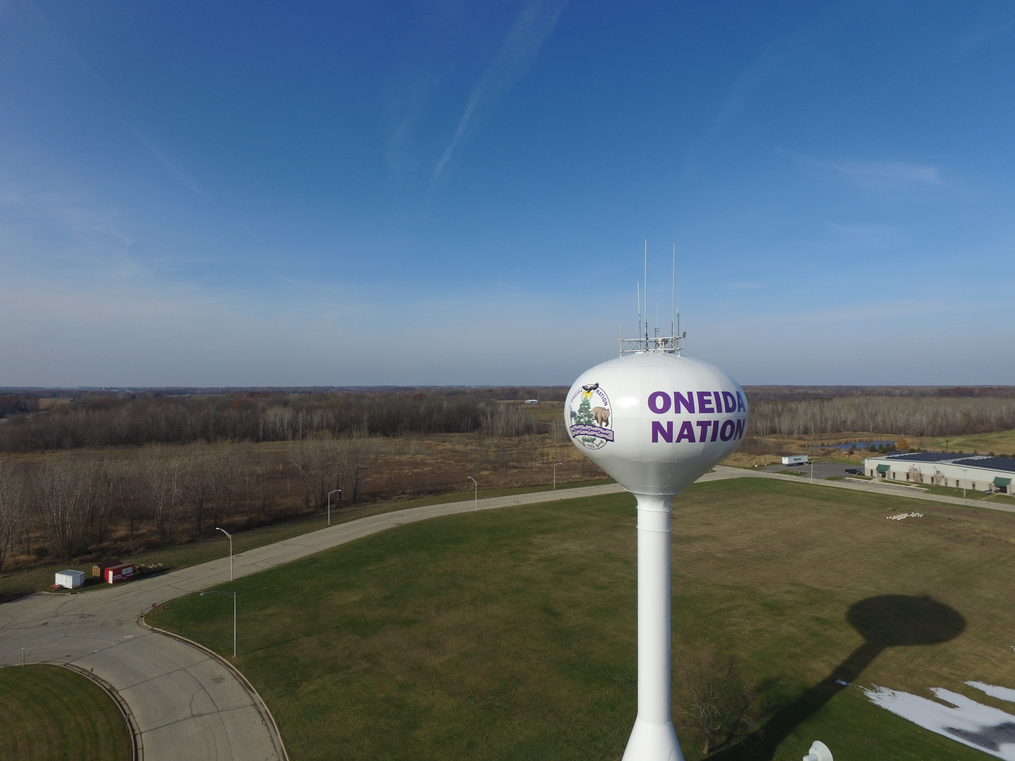
Oneida Utility customers located within the Sandhill Circle area receive their water from a single groundwater well in the community.
HEALTH INFORMATION
Drinking water, including bottled water, may reasonably be expected to contain at least small amounts of some contaminants. The presence of contaminants does not necessarily indicate that water poses a health risk. More information about contaminants and potential health effects can be obtained by calling the Environmental Protection Agency’s Safe Drinking Water Hotline (800) 426-4791.

DETECTED CONTAMINANTS
Your water was tested for many contaminants last year. Most water monitoring testing occurs every three (3) years, except for annual reporting for nitrates, and monthly reporting for total coliform bacteria reporting. This report lists only those contaminants which were detected in your water and have enforceable standards assigned to them. Enforceable standards consider safe levels for human consumption for various contaminants; the standards could be in the form of either a Health Advisory Level (HAL) or a Secondary Maximum Contaminant Level (SMCL), or both. Health Advisory Levels identify at which concentration levels contaminants in drinking water present health risks. Secondary Maximum Contaminant Levels are levels that do not present health concerns but may pose aesthetic problems such as objectionable taste, odor or color.

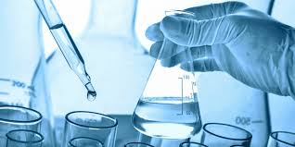
The following tables list contaminants which were detected in your water and that have either a Health Advisory Level (HAL) or a Secondary Maximum Contaminant Level (SMCL), or both. Test results that were “negative” or showed “no detected levels” of contaminants are not reported in these tables. If the contaminant was not monitored last year, but was detected within the past 5 years, it will appear in the tables below and on the next page along with the sample date.
SANDHILL CIRCLE
PWSI# 55295705

CONTAMINANTS – TESTED 2023
PARAMETERS | MCL | LEVEL | TYPICAL SOURCE OF CONTAMINANTS
Fluoride | 4 | 1.1 mg/L | Erosion of natural deposits, water additive which promotes strong teeth, & discharge from fertilizer
Nitrate | 10 | <0.044 mg/L | Runoff from fertilizer use, leaching from septic tanks, sewage, & erosion of natural deposits
Iron | 0.3 | 0.160 mg/L | Natural existence in underground rock formation and precipitation water that infiltrates through these formations.
Hardness | n/a | 243 mg/L | Dissolved calcium and magnesium the end product of dissolving limestone from soil and rock materials.

INORGANIC CONTAMINANTS – TESTED IN 2021
PARAMETERS | MCL OR AL | DETECTED LEVEL | TYPICAL SOURCE OF CONTAMINANTS
Fluoride (ppm) | 4 | 1.0 | Erosion of natural deposits, water additive which promotes strong teeth, and discharge from fertilizer.
Nitrate (ppm) | 10 | <0.044 | Runoff from fertilizer use, leaching from septic tanks, sewage, and erosion of natural deposits.
Asbestos (MFL) | 7 | ND | Decay of Asbestos Cement Water Mains; erosion of natural deposits.
Antimony (ppb) | 6 | <0.14 | Discharge from petroleum refineries, fire retardants, ceramics, electronics and solder.
Arsenic (ppb) | 10 | <0.14 | Erosion of natural deposits; runoff from orchards; runoff from glass and electronics production wastes.
Barium (ppb) | 200 | 80.4 | Discharge of drilling wastes; discharge from metal refineries; erosion of natural deposits.
Beryllium (ppb) | 4 | <0.036 | Discharge from metal refineries and coal-burning factories; discharge from electrical, aerospace, and defense industries.
Cadmium (ppb) | 5 | <0.027 | Corrosion of galvanized pipes; erosion of natural deposits; discharge from metal refineries; runoff from waste batteries and paints.
Chromium (ppb) | 100 | <0.64 | Discharge from steel and pulp mills; erosion of natural deposits.
Cyanide (ppm) | 0.2 | <0.0018 | Discharge from steel or metal factories; discharge from plastic and fertilizer factories.
Mercury (ppb) | 2 | <0.12 | Erosion of natural deposits; discharge from refineries and factories; runoff from landfills; runoff from cropland.
Nickel (ppb) | 100 | 0.41 | Naturally occurring in soil.
Selenium (ppb) | 50 | 0.87 | Discharge from petroleum and metal refineries; erosion of natural deposits; discharge from mines.
Thallium (ppb) | 2 | ND | Leaching from ore-processing sites; discharge from electronics, glass, and drug factories.
Lead (ppm) | 0.015 | 0.00081 | Corrosion of household plumbing systems; erosion of natural deposits.
Copper (ppm) | 1.300 | 0.0181 | Corrosion of household plumbing systems; erosion of natural deposits.
MICROBIOLOGICAL – TESTED 202
PARAMETERS (UNITS) | MCL | DETECTED LEVEL | TYPICAL SOURCE
Total Coliform Bacteria (Safe/Unsafe) | 0 | ND | Naturally present in the environment
RADIOACTIVE CONTAMINANTS – 2022
PARAMETERS | MCL | DETECTED LEVEL | TYPICAL SOURCE
Total Radium 226 & 228 Activity | 5 | 3.876 pCi/L | Naturally present in the environment, erosion of natural deposits
Gross Alpha | 15 | 6.28 pCi/L | Erosion of natural deposits

 | VOLATILE ORGANIC CONTAMINANTS – TESTED IN 2023
PARAMETERS |  | LOD | MCL | DETECTED LEVEL (ppb) µg/L | TYPICAL SOURCE OF CONTAMINANTS
Benzene |  | 0.11 | 5 | ND | By-products of industrial processes and petroleum production, and can also come from gas stations, urban storm water runoff, and septic systems
Carbon tetrachloride |  | 0.19 | 5 | ND | Same as above
1,2-Dichlorobenzene |  | 0.32 | 600 | ND | Same as above
1,4-Dichlorobenzene |  | 0.29 | 75 | ND | Same as above
1,2-Dichloroethane |  | 0.13 | 5 | ND | Same as above
1,1-Dichloroethene |  | 0.14 | 7 | ND | Same as above
Cis-1,2-Dichloroethene |  | 0.15 | 70 | ND | Same as above
Trans-1,2-Dichloroethene |  | 0.11 | 100 | ND | Same as above
Dichloromethane |  | 0.38 | 5 | ND | Same as above
1,2-Dichloropropane |  | 0.16 | 5 | ND | Same as above
Ethylbenzene |  | 0.21 | 700 | ND | Same as above
Chlorobenzene |  | 0.20 | 100 | ND | Same as above
Styrene |  | 0.19 | 100 | ND | Same as above
Tetrachloroethene |  | 0.49 | 5 | ND | Same as above
Toluene |  | 0.17 | 1000 | ND | Same as above
1,2,4-Trichlorobenzene |  | 0.28 | 70 | ND | Same as above
1,1,1-Trichloroethane |  | 0.15 | 200 | ND | Same as above
1,1,2-Trichloroethane |  | 0.21 | 5 | ND | Same as above
1,1,2-Trichloroethene |  | 0.17 | 5 | ND | Same as above
Vinyl chloride |  | 0.087 | 0.2 | ND | Same as above
Xylene (total) |  | 0.73 | 1000 | ND | Same as above

The Oneida Nation Water Utility has no violations for detections of contaminants that exceed Health Advisory Levels, Ground Water Standards or Secondary Maximum Contaminant Levels.
PARTICIPATION IN VOLUNTARY EPA STUDY FOR UNREGULATED CONTAMINANTS (PFAS)
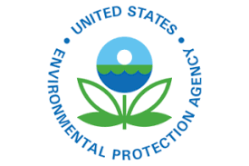
The Oneida Nation Water Utility participated in a voluntary study with the EPA related to PFAS. PFAS are contaminants of emerging concern that are not yet regulated. Unregulated contaminants are those for which EPA has not established drinking water standards. The purpose of unregulated contaminant monitoring is to assist EPA in determining the occurrence of unregulated contaminants in drinking water and whether future regulation is warranted. Perfluoroalkyl and polyfluoroalkyl substances (PFAS) are a large group of human-made chemicals that have been used in industry and consumer products worldwide since the 1950s. These chemicals are all around us in water bottles, fast food wrappers, toilet paper, rain jackets, the list goes on and on.

There are no detectable levels of PFAS in the drinking water provided by the Oneida Nation Water Utility. The first samples for PFAS were collected by the EPA as part of the voluntary study in December 2022. The results of those samples were received February 28, 2022. One well sample, from the Norbert Hill Center well, resulted in “no detectable levels” of PFAS. The second well, the Site 1 well, detected PFAS at the level of 2.2 parts per trillion (PPT). Upon receipt of the results, the Utilities Team immediately consulted with EPA and Oneida Sustainment Restoration Services (SRS), a leader in PFAS consulting. Both the EPA and SRS explained that science is currently only able to detect PFAS levels to 2.0 PPT; that PFAS detection at levels as low as 2.2 PPT could be the result of a contaminated sample; and that PFAS samples can be easily contaminated due to the prevalence of the PFAS chemicals in everyday materials. The Site 1 well was retested for PFAS by SRS in March 2023. SRS tested for PFAS using the same testing standard used by the EPA and sent the samples to labs accepted by the EPA. The SRS retest of the site 1 well for PFAS returned the result “no detectable levels”. The EPA also retested the Site 1 well for PFAS in March 2023. We received those results in April 2023, the EPA’s retest results also confirmed “no detectable levels” of PFAS in the Site 1 well.
Although there are currently no detectable levels of PFAS in the drinking water provided by the Utility, PFAS is all around us, so the Nation will continue monitoring for PFAS in Oneida’s drinking water to ensure our water remains safe for consumption.
More information about PFAS can be found here: https://www.epa.gov/pfas.
The EPA’s DRAFT PFAS regulations: https://www.regulations.gov/document/EPA-HQ-OW-2022-0114-0027.

IMPORTANT INFORMATION
Some people may be more vulnerable to contaminants in drinking water than the general population. Immuno-compromised persons such as persons with cancer undergoing chemotherapy, persons who have undergone organ transplants, people with HIV/AIDS or other immune system disorders, some elderly, and infants can be particularly at risk from infections. These people should seek advice about drinking water from their health care providers. EPA/ Center for Disease Control guidelines on appropriate means to lessen the risk of infection by microbial contaminants are available from the Environmental Protection Agency’s Safe Drinking Water Hotline (800-426-4791).

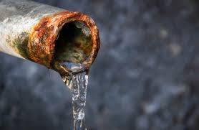
Lead – If present, elevated levels of lead can cause serious health problems, especially for pregnant women and young children. Infants and children who drink water containing lead in excess of the action level could experience delays in their physical or mental development. Children could show slight deficits in attention span and learning abilities. Adults who drink this water over many years could develop kidney problems or high blood pressure. Lead in drinking water is primarily from materials and components associated with service lines and home plumbing. The Oneida Water Utility is responsible for providing high quality drinking water but cannot control the variety of materials used in various plumbing components. When your water has been sitting for several hours, you can minimize the potential for lead exposure by flushing your tap for 30 seconds to 2 minutes before using water for drinking or cooking. If you are concerned about lead in your water, you may wish to have your water tested. Information on lead in drinking water, testing methods, and steps you can take to minimize exposure is available from the Safe Drinking Water Hotline (800-426-4791) or at www.epa.gov/safewater/lead.

Radium – Radium is radioactive and is found in small quantities in nature. Radium is a decay product of uranium and thorium. In addition to occurring naturally in the environment, radium may also be released into the environment by human activity. Exposure to radium over a period of many years may result in an increased risk of some types of cancer, particularly lung and bone cancer. Higher doses of radium have been shown to cause effects on the blood (anemia), eyes (cataracts), teeth (broken teeth), and bones (reduced bone growth). The Oneida Water Utility regularly monitors radium levels in our drinking water and the radium levels in our water are beneath well beneath the levels at which radium drinking water notices are required (when levels are detected at 5 parts per billion or greater). Still, because radium is naturally occurring in ground water, there will likely always be some radium in the Oneida Utility drinking water.

FUTURE DEVELOPMENTS
The Oneida Nation Water Utility already provides excellent drinking water and we are always looking towards future developments that can improve the quality of our water. As we have reported in previous annual reports, the Nation is working with Indian Health Services to build a new drinking water well located on King Lane. The construction of this well is mindful of the radium levels naturally occurring in our water supply and includes a filtration system (is this in addition to or instead of the chlorine). Our new well will have a media filter that is highly effective at removing most of the radium and iron when the new well is complete during the second half of 2024. The Nation will stop using the existing wells that currently serve this drinking water system as the primary water source although they may be relied upon as a backup water source as needed. We are looking forward to integrating this new well into our water system to enhance the quality of our drinking water and we will continue to provide updates as the project progresses!

If you have any questions regarding the quality of your water or billing purposes, please don’t hesitate to contact Scott Cottrell, Utilities Manager at 920-496-5290 between the hours of
8 A.M. and 4 P.M (the Utility is closed from 12 PM to 1 PM).

