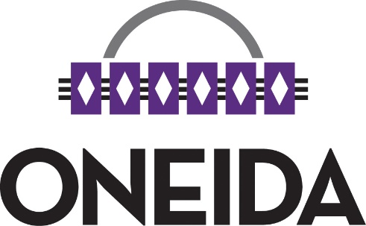

|  |
| --- |
| **Final COVID-19 Update VI  for Oneida Tribal Members**  *“7 Generations thinking is not a slogan or fad; it is a thought process enrooted in hundreds of years of decision-making that has protected our people since time immemorial. COVID-19 has the potential to wipe out our 17,308 members - the decisions we make today are truly to ensure our people have a future.”*  *- Oneida Business Committee* |
|  |
| Since mid-January 2020, the Oneida Business Committee (OBC) has been aware of the COVID-19 coronavirus. Currently, Oneida has made the transition from recovery to the rebuilding phase and continues to work diligently to lessen the health & financial impacts of the COVID-19 pandemic on the community. The report herein is a synopsis of the actions taken from the beginning of January 2021 through July 2023. |

|  |  |  |
| --- | --- | --- |
| Overview This Sixth and final report will focus on general information and activities of the Oneida Nation from January 2021 through July 2023. The Covid-19 updates have been prepared and distributed to Tribal members throughout the pandemic providing details about activities and information that have occurred throughout the Oneida Nation’s Public Health State of Emergency. We believe these reports are important in absence of the regularly held Semi-annual General Tribal Council (GTC) meeting, which normally takes place in July of each year.  As an overview, Chairman Tehassi Hill has shared a message on behalf of the Nation. Additionally, the information series covered in this report is as follows:   1. COVID-19 Statistics & Vaccination 2. “Response” and “Recovery” Phase Update 3. Re-Opening/New Normal 4. Cares Act & ARPA/FRF 5. GWE vs. Per Capita 6. 2020-2023 OBC Broad Goals 7. Reporting and Communications   Questions about this latest report can be directed to any of the Oneida Business Committee Members, whose contact information is located on the Oneida Nation website here:  <https://oneida-nsn.gov/government/business-committee/members/> | **Highlights of Events & Actions Taken** • • • | January 2021: • Public Health State of Emergency extended to February 11, 2021.  • Higher education funding returns back to original grant amounts for all semesters/terms.   * Oneida Health Center holds first COVID-19 vaccination clinic for those 65 & older.   February 2021:  • Retail holds customer appreciation for essential employees (health, police, firefighters, education, c-store, grocery & casino)   * All Oneida employees become eligible to receive the vaccine from Oneida Community Health Center   March 2021:  • Persons 55 & older become eligible to receive the COVID-19 vaccine.   * OBC extends public health state of emergency. * President Biden signs the American Rescue Plan Act of 2021. * Virtual language open house event is completed * WI Supreme Court strikes down statewide mask mandate. |

**Part I – COVID-19 Statistics & Vaccination Update**

# **Highlights of Events & Actions Taken**

• • •

April 2021:

• Elder meals still available continue to be available by pick up & Meals on Wheels continue to be delivered daily.

* Fitness center reopens by appointment
* Museum gift shop & Library reopen under safety plans
* Emergency Rental Assistance Program is in place and accepting applications.
* Awareness T-Shirt to prevent spread of COVID-19 are distributed.

May 2021:

• Oneida Child support holds virtual mothers’ day drive-thru event.

* FDA Authorizes Pfizer vaccine (emergency use) for ages 12-15.
* OBC extends Public Health State of Emergency to June.

June 2021:

* OBC adopts the Fiscal Recovery Fund spending plan by resolution 06-09-21-B (ARPA Fund uses).
* OBC extends Public Health State of Emergency to July.
* OBC approves direct payments to membership under GWE.
* OBC approves vaccine incentive Program.

COVID-19 Update V for

Oneida Tribal Members

**COVID-19 ILLNESS DATA**

During the spring of 2021, data indicated a trend that showed there had been a significant decline in COVID-19 testing in our area, including a decline in new COVID-19 cases. However, the most current data available at the time of this report, showed this trend is short-lived. During the summer of 2021, the Nation continued to monitor numbers daily, and prepared to continue taking necessary actions to mitigate the continued spread of this disease.

At the time of this report, trends in hospitalization and severe complications associated with COVID-19 illness continued to be prevalent amongst individuals that had not been vaccinated. The Nation held the position that vaccination is a key tool in reaching community immunity and protecting our overall population.

The below graph was created in 2021 and represented the number of COVID-19 positive cases by location, including the United States, Wisconsin, Brown County, Outagamie County, and the Oneida Nation Reservation. As displayed, the Native American population represents the highest population percentage (14.71%) of the COVID-19 cases.

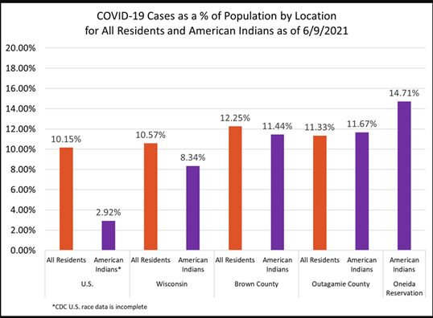

**As of 06/10/2021**, the COVID-19 data for positive cases, active cases and deaths are reported in the below chart. This information was updated frequently and was available on the Oneida Nation’s website through May 11, 2023, which was the last day of the Public Health State of Emergency.

|  |  |  |  |
| --- | --- | --- | --- |
| **Oneida Health Jurisdiction** | **Positive (Confirmed Cases)** | **Active Cases** | **Deaths** |
| Oneida – Totals | 807 | 3 | 10 |
| Oneida Nation - Outagamie County | 344 | 1 | 6 |
| Oneida Nation - Brown County | 463 | 2 | 4 |

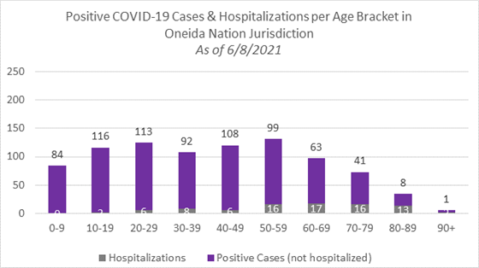The below chart represented the number of positive COVID -19 cases and the rate of hospitalization by age groups as of June 8, 2021.

**VACCINATION DEMOGRAPHICS**

Early in 2021, there were two COVID-19 vaccines authorized by the U.S. Food and Drug Administration (FDA); the Pfizer & Moderna that requires 2 doses, and the Johnson & Johnson that requires 1 dose. The COVID-19 vaccine was hard to obtain until April 2021 when a significant improvement in availability of COVID-19 vaccine occurred.

In April 2021, a vaccine safety monitoring system acted to temporarily pause the use of the Johnson & Johnson COVID-19 vaccine to allow a thorough safety review by the FDA and Centers for Disease Control and Prevention (CDC). This pause was initiated when the monitoring systems noted a severe type of blood clot condition in a handful of individuals that had received the Johnson and Johnson COVID-19 vaccine in the preceding week. By the end of April 2021, it was determined that although a small risk noted, the benefits of receiving the vaccine were far greater and the Johnson and Johnson vaccine was able to continue to be used.

By May 2021, there was a decline in individuals choosing to be vaccinated. This was a phenomenon recognized across the country. Early on, the Native American population vaccination rate was comparable to all residents in Wisconsin. However, in the spring of 2021 there was a significant difference with fewer Native Americans choosing to be vaccinated. This is concerning because the Native American population have been disproportionately affected by COVID-19 illness and the complications.

In early May 2021, a COVID-19 vaccine was not available for children under 12 years of age although there were trials underway to evaluate the effectiveness and safety in children under 12 years of age. In November 2022, Covid-19 vaccine for children between the ages of 5-11 was approved by the Federal Drug Administration (FDA) on an emergency basis. Until then, COVID-19 safety measures such as masking, frequent hand washing, and social distancing were highly encouraged to protect this age group.

The below chart represents the COVID-19 vaccination data locally in Brown and Outagamie Counties, around June **11, 2021.**

|  |  |  |  |  |
| --- | --- | --- | --- | --- |
| Location | All WI Residents Fully vaccinated | All WI Residents  Not fully vaccinated | WI American Indian Fully vaccinated | WI American Indian  Not fully vaccinated |
| Wisconsin | 43.8% | 56.2% | 27.0% | 73.0% |
| Brown | 44.3% | 55.7% | 29.0% | 71.0% |
| Outagamie | 42.5% | 57.5% | 26.1% | 73.9% |

**ONEIDA NATION VACCINATION CLINICS**- [https://oneida-nsn.gov/connect/news/oneida-nation-covid-19-resource-page/#COVID-19-Vaccine-Data](https://oneida-nsn.gov/connect/news/oneida-nation-covid-19-resource-page/#COVID-19-Vaccine-Data )

The majority of the COVID-19 vaccine utilized in the Oneida Nation vaccination clinics had been the Moderna vaccine. In May 2021, when the FDA authorized use of the Pfizer vaccine for those 12 years and older, the Nation began offering Pfizer vaccine clinics to ensure this population of members had access to the vaccination. Both the Moderna and Pfizer COVID-19 vaccines required 2 doses to complete the series and for the individual to be considered fully vaccinated. The single dose Johnson & Johnson vaccine clinics were held in the months thereafter.

**Below are the number of vaccinations administered by the Oneida Nation:**

|  |  |
| --- | --- |
| Month | # of Vaccinations Administered |
| February 2021 | 1,332 |
| March 2021 | 2,399 |
| April 2021 | 1,461 |
| May 2021 | 474 |
| June 2021 | 460 |

**WHY IS VACCATION IMPORTANT TO OUR COMMUNITY?**

The Oneida Nation was very diligent in maintaining COVID-19 safety precautions. A state of Public Health Emergency had been in effect since March 12, 2020, and continued through May 11, 2023.

At that time, people of any age with certain underlying medical conditions were at increased risk for severe COVID-19 illness. Data demonstrated Native American populations were disproportionately affected by certain underlying medical conditions. This contributed to greater risk of COVID-19 illness and its complications in our community. The chart and information below, demonstrated the underlying medical conditions that were at an increased risk for severe COVID-19 illnesses.

**WISCONSIN, BROWN, AND OUTAGAMIE COUNTIES**- ([CDC COVID Data Tracker](https://covid.cdc.gov/covid-data-tracker/#underlying-med-conditions)).

|  |  |  |
| --- | --- | --- |
| Underlying medical conditions at increased risk for severe COVID-19 associated illness | WI, Brown  County | WI Outagamie County |
| Chronic kidney disease | 2.7% | 2.6% |
| Chronic Obstructive Pulmonary Disease (COPD) | 6% | 5.8% |
| Heart Disease | 6.1% | 5.9% |
| Diagnosed diabetes | 9.1% | 8.7% |
| Obesity | 33.1% | 32% |
| *2018 Behavioral Risk Factor Surveillance System (BRFSS) | | |

**WI DHS- WI Asthma Statistics**

[https://www.dhs.wisconsin.gov/asthma/facts.htm](https://www.dhs.wisconsin.gov/asthma/facts.htm%20)

* Asthma is common. 1 in 11 adults. 1 in 12 children.
* Asthma is deadly. Children have a 3X higher asthma emergency department rate compared to adults
* American Indian/ Alaska Native 2.5X higher (than white and Asian populations)

**WI DHS- WI Burden of Asthma Report 2020**

<https://www.dhs.wisconsin.gov/publications/p02412-20.pdf>

* In WI, the asthma burden disproportionately falls upon racial and ethnic minority populations. …American Indians have an asthma prevalence almost twice that of whites.
* American Indian asthma prevalence 15% (WI asthma prevalence 9%)

**WI DHS- Chronic Disease Prevention Data and Reports**

<https://www.dhs.wisconsin.gov/disease/burden-chronic.htm>

* In WI racial and ethnic minority populations suffer higher rates of hypertension, diabetes, and obesity.
* Non-Hispanic American Indian diabetes rate is 21%.
* In 2016, Native American in WI self-reported diabetes rates nearly three times higher than non-Hispanic Whites.
* Non-Hispanic American Indian Obesity rate 52%
* Non-Hispanic American Indian Hypertension rate 36%

**ONEIDA COMMUNITY SPECIFIC DATA**

According to the last Oneida Health Study, here are the health comparisons for those illnesses for enrolled Oneida ADULTS in Brown & Outagamie Counties. Below are some data points pulled from the 2017 Community Health Assessment Survey. These rates are age-adjusted:

* Obesity: 54% are obese and another 31% are overweight.
* Diabetes: 21% have been told they have diabetes.
* Heart Disease: 4% have been told they had a heart attack. 4% have been told they have angina or coronary heart disease.
* COPD: Higher rates of tobacco use. Only 40% have never smoked regularly compared to 60% of the general public in Brown & Outagamie Counties (compared in 2017). Higher rates of asthma. 21% have been diagnosed with asthma compared to 7% of the general public in Brown & Outagamie Counties (compared in 2017).

The health statistics demonstrated above indicated that our community was at high risk to suffer from the sever illnesses that can be brought on by the COVID-19 virus. It was for those reasons, and the protection of our people, that vaccination was encouraged. Vaccination was free and there were many stores, pharmacies and health clinics that administered the vaccine.

**CONTRIBUTIONS FROM ONEIDA COMPREHENSIVE HEALTH DIVISION**

COVID-19 has often been described as an event of a lifetime. Though few would have predicted we would be actively responding for three years.

The Oneida Comprehensive Health Division (OCHD) lead the health response to the COVID-19 pandemic in the Oneida Community. Oneida’s COVID-19 health response team leadership regularly met with Oneida Business Committee to assure the most current information was available.

OCHD had been organized in an Incident Command Structure (ICS) from April 2020 – June 2023. This emergency management structure allowed us to maximize the skills and abilities of the workforce. Staff were organized in a specific way to allow focus. OCHD reviewed the COVID-19 health response efforts every 6 months, capturing the evaluation in After Action Reports (AARs).

During 2022 and through the first half of 2023, teams focused on activities around testing, contact tracing, vaccination, assisting departments and event coordinators with safe operating plans all while finding our way back to providing direct care programs and services.

OCHD was a resource to employees within the organization, offering regular “Tune-in-Tuesday” education sessions and being an ongoing resource to employees on all things COVID-19.

When the public health emergency ended May 11, 2023, Oneida’s COVID-19 health response team remained in ICS for a few additional weeks to make sure we could quickly pivot should any unexpected consequences occur.

Measurable outcomes from Oneida’s COVID-19 health response activities April 2020 thru July 2023:

1. Number of COVID-19 Tests completed = 15,026 (see graph A).
2. Number of COVID-19 at home test kits ordered for distribution= 21,515(see graph B).
3. Number of COVID-19 cases for Oneida Nation Jurisdiction= 2,245 (see graph C).
4. Number of COVID-19 Vaccine administered= 13,817 (see graph D).

**Making evidenced-based and data driven decisions**

Early in the pandemic, Oneida’s COVID-19 health response team made conscious effort to make decisions around available data and science. As you can image, this was not always easy and not always as timely as we would have preferred. But data consistently demonstrated the Native American population in WI was disproportionately impacted by COVID-19; more case counts, serious complications and deaths than other populations in WI. Additionally, COVID-19 vaccination rates were lower than other populations in WI. As a result, Oneida’s COVID-19 health response team often recommended stronger mitigation measures that lasted for longer periods of time when compared to other jurisdictions.

As unpopular as some of the mitigation measures were, we knew lives were being saved. Implementing these strong mitigation measures helped protect our most vulnerable community members. Consistently low infection rates among our residents at the Anna John Resident Centered Care Community (AJRCCC) is a good example of success with such efforts.

With the ending of the public health emergency May 11, 2023, some of the data collection requirements ended. No longer having this data meant some of the data metrics we had been monitoring also ended.

**How to stay safe**

By 2022, we knew a lot more about COVID-19 illness and were monitoring variants of the original strain.

In partnership with Oneida Communications Department, OCHD representatives offered weekly COVID-19 public health updates on Facebook live. This was just one of the many strategies used to assure the community had access to the most up to date information around the pandemic.

During 2022, we recommended the general public monitor COVID-19 Community Levels when considering an individual’s risk to COVID-19. Healthcare entities monitored COVID-19 Transmission Levels for implementing specific mitigation measure within healthcare facilities such as wearing masks.

We saw creative approaches to providing programs and services in a safe manner for both staff and customers. While many programs and services returned to an in-person delivery system, others remained in virtual or a hybrid of in-person and virtual delivery systems.

Great effort occurred to educate the community on the importance of staying up to date on COVID-19 vaccination. OCHD continued to offer vaccination clinics throughout 2022 and the first half of 2023, well after most community vaccination sites in WI were discontinued. Vaccination guidance continued to evolve and change throughout 2022 and the first half of 2023. OCHD worked diligently to provide the Oneida Community with the most up to date information around COVID-19 vaccination and boosters.

**Contact Tracing**

Throughout 2022, Oneida continued to provide contact tracing and disease investigation as part of our COVID-19 response for the Oneida jurisdiction, even though most other public health departments had discontinued individual contact investigations. In the second half of 2022, we did update our contact tracing processes moving away from contacting every positive patient by phone to sending letters that included a phone number to reach out to us for any questions regarding isolation or quarantine guidance.

**Partners and collaboration**

Throughout the pandemic, Oneida leveraged both established and newly created collaborations and partnerships in effort to maximize available services to Oneida Tribal Members and their families. Oneida routinely collaborated with other local healthcare systems on communication around additional testing and vaccination opportunities available to tribal members.

**Looking to the future**

COVID-19 is still circulating globally. Protection from previous COVID-19 vaccinations or prior COVID-19 infections wanes over time. Staying up to date on your COVID-19 vaccination continues to help provide additional protection beyond that received by prior vaccine doses or infections.

Bivalent COVID-19 vaccines remain available and continues to demonstrate effectiveness against severe COVID-19 infections and hospitalizations. The Bivalent COVID-19 vaccine continues to be available at the Oneida Community Health Center by appointment.

Come this Fall, the COVID-19 vaccine will be updated to a monovalent vaccine to include the current circulating variant for better protection this fall and winter season. The Centers for Disease Control and Prevention (CDC) will continue to provide the recommendations and guidelines on who should be vaccinated and when they should receive the updated monovalent vaccine when it becomes available. Once these standards are in place, we will provide this information to the Oneida Community. We are anticipating receiving this vaccine late Fall 2023. A walk-in COVID-19 vaccination clinic will be held at a future date this Fall/Winter. Please watch for future announcements as these dates/ times are determined.

Graph A: OCHC Laboratory COVID-19 testing data as of 07/25/23

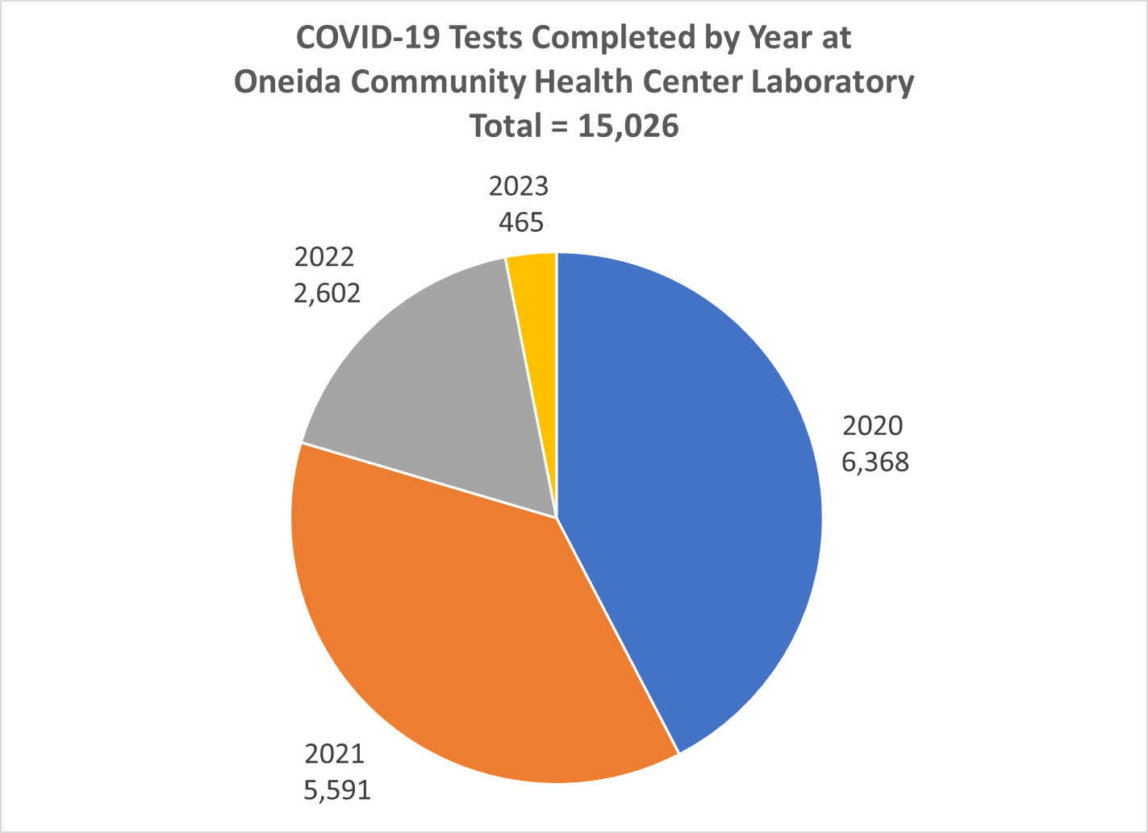

Graph B: COVID-19 at home test kits ordered for distribution of as of 07/26/23

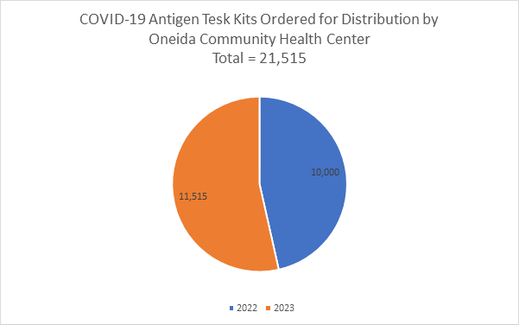

Graph C: COVID-19 cases for Oneida Nation Jurisdiction by year as of 07/26/23

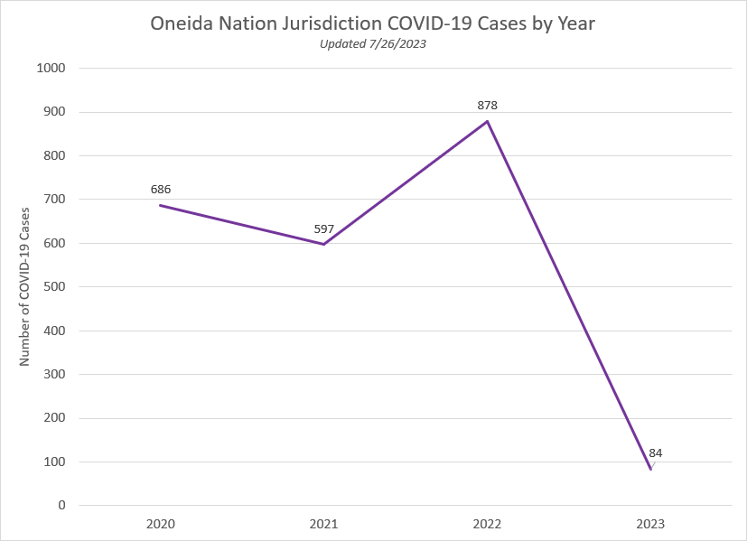

Graph D: OCHC COVID-19 vaccination data as of 07/25/23

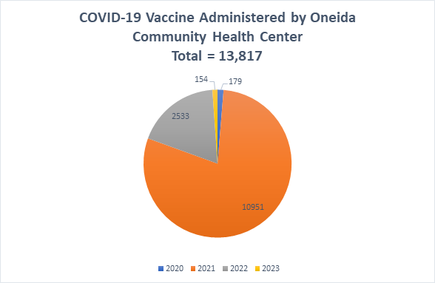

## Part II – “Response” and “Recovery” Phase Update

The Nation continued to be in the response phase in addressing this global pandemic; although some activities appeared to have started returning to “normal” or to pre-pandemic levels, this disease was not out of our area, and was still negatively impacting tribal members health, safety, and general welfare.

However, progress had started toward recovery and the Nation is beginning to see the return of some limited programming and staffing levels. The Nation’s operational leadership has had many changes in this reporting period, including the changes in key positions, and the consolidation of some divisions and departments. The Nation’s operations will continue to assess when and how areas will be recharged and make determination on service delivery modifications or continuations, as needed. The Nation is not back to pre-pandemic staff levels (still about 1,000 fewer employees during this reporting period); the Nation continues to seek the community’s patience and understanding as the Nation works toward long-term financial sustainability as it relates to recovery efforts.

Additionally, the Nation continues to work closely with partners in Oneida’s public health, healthcare, and emergency management to ensure that we are monitoring the many impacts of the pandemic and making decisions to be responsive, with the best interest of community health, safety, and welfare at the forefront.

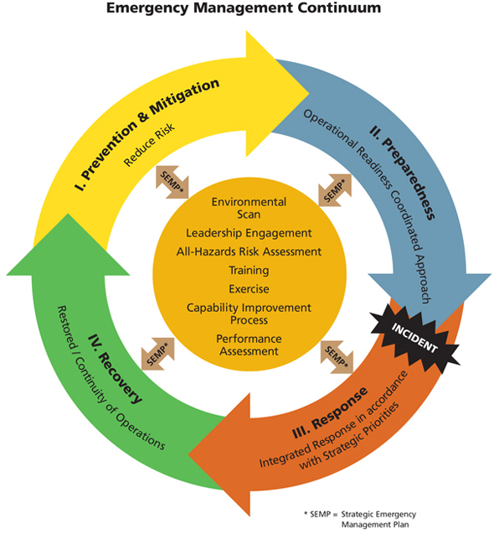

* Mitigation: most cost-efficient method for reducing the impact of hazards as this is where the risks are identified and includes financial risks.
* Preparedness: a continuous cycle of planning, organizing, training, and evaluating.
* Response: includes the mobilization of the identified emergency staff or teams to respond to an event.
* Recovery: the phase is to restore the affected area(s), including plans for restoring facilities and employment.

As a reminder, the Emergency Management continuum represented the cycle that the Nation used in response to the COVID-19 pandemic. The Oneida Nation continues to be in the ”Recovery” phase of the Emergency Management continuum.

## Part III – Reopening/New Normal

During the summer of 2021, many programs and services started to resume regular programming. For all areas, Tribal membership were encouraged to call ahead to confirm hours of operation, masking requirements, and available services.

Some departments continued to require masks of employees, patients, clients, and visitors. Examples consisted of Oneida Comprehensive Health Services, Anna John Resident Centered Care Community, Aging and Disability Services, and Childcare.

Please keep in mind that many departments faced two main challenges to resuming their full level of services. Due to the financial impact of the pandemic, many areas were (1) required to reduce their staffing and (2) required to reduce their budgets. As a result, some programs/services did not fully resume until after the start of the new fiscal year on October 1, 2021.

The following are specific areas of high interest (the departmental information below highlights the availability of services at the time of reporting):

Oneida Comprehensive Health Division

**Medical Clinic** - Open 8:00am-4.30pm, Monday - Friday. Please contact the Triage nurses at (920) 869-2711 to discuss your needs for services. No walk-ins.

**Dental** - Open 7:00am-5:00pm, Monday – Friday. Call the Dental PAR’s to discuss your needs and/or to be triaged.They can be reached at (920)869-4916**.** Currently scheduling dental cleanings, urgent & emergent care, and limited prosthodontics for dentures & partial dentures. No walk-ins.

**Behavioral Health** – Open 8:00am-4:30pm, Monday – Friday. Please call Behavioral Health Triage at (920) 490-3860 for telehealth services. Opioid Overdose Emergency Kits available by calling (920) 490-3790**.** No walk-ins.

Education and Training

**Head Start/Early Head Start** – In-person summer school is available for 4-year-old students to ensure they are kindergarten ready.

**Oneida Higher Education** – Scholarship awards continue to be processed with pre-COVID funding tiers. Staff are available to students by appointment only.

Governmental Services Division

**Oneida Nation Arts Program** – Staff are in the office on a regular basis, and open to the public by appointment only.

**Oneida Recreation** – Limited staff have returned and are developing summer programming. Please call (920) 869-6291 for more information.

**Family Fitness** – Open to the public by appointment. Fitness classes available in the gymnasium. Experiential programming coming soon! The pool is closed for repairs. Please call (920) 490-3918 to make an appointment.

Trust Enrollment Department

Trust Enrollments remains available by phone by calling (920) 869-6200 or email ([TrustEnrollments@OneidaNation.org](mailto:TrustEnrollments@OneidaNation.org)) during business hours. Please call to schedule an appointment for in-person services. Finally, if a member is looking to submit a Per Capita form or Minors Trust Claim/Deferral form, an outdoor, distanced service option available at our Enrollment office on Tuesdays and Thursday from 9:00am – Noon.

GTC Meetings

Holding General Tribal Council Meetings is one of the most important functions in our representative form of government. The Oneida Business Committee has been monitoring local disease activity, reviewing potential venue options, and associated legal hurdles that come with alternative venues, and has begun planning for alternative participation methods (i.e., virtual meetings) in the future. To date, there are three GTC meetings which are planned; however, these dates may be moved into the future based on disease activity and the ability of the Nation to hold a meeting in a manner that limits or mitigations disease transmission.

## Part IV – The Coronavirus Aid, Relief and Economic Security Act (CARES Act) and the American Rescue Plan Act (ARPA)

The Oneida Nation received federal funding from many different sources during the pandemic. The two primary sources were the Coronavirus Aid, Relief and Economic Security Act (CARES Act) which was utilized during calendar year 2020, and most recently, through the America Rescue Plan Act (ARPA) for fiscal years 2021 through 2023.

**Coronavirus Aid, Relief and Economic Security Act (CARES Act):**

CARES Act funding involved direct payments to the Oneida Nation funds that were restricted to specific uses such as health care, or fit within the parameters of three restrictions:

* Must be a necessary expenditure incurred due to the public health emergency with respect to COVID-19.
* Expenditure was not accounted for in the budget most recently approved as of March 27, 2020.
* Expenditure was incurred during the period of March 1, 2020 through December 30, 2020.

Based on the restrictions outlined above, and the emerging pandemic impact of COVID-19, the funding was allocated and spending to meet immediate needs. This involved direct membership assistance (about 46%), payroll for employees with direct responsibility for COVID-19 response (about 19%) and compliance activities to meet health and safety needs for our employees and customers as some operations re-opened or remained open during the pandemic (about 12%). The chart below identifies in broad categories how the CARES Act funds were used.



The final report for these payments is located at <https://oneida-nsn.gov/oneida-nation-cares-funding-expenditures/> or through the QR code below.

QR Code

Oneida Nation reporting on CARES Act funds usage.

This website contains a brief explanation of the CARES Act and its funding use restrictions. There is also a link to a spreadsheet which identifies the approved uses for CARES Act funds. CARES Act funds were approved through a process adopted in resolution # BC-06-10-20-B, Process for Authorization for Use of CARES Act Covid Relief Funds.

**American Rescue Plan Act (ARPA):**

The American Rescue Plan Act (ARPA) is a three-year funding resource for federal, state, and tribal governments. The Oneida Nation received three sets of funding. The first is based on a formula of equal share of $1 billion for each tribal government. The Oneida Nation received $1,742,160.27 million. The second set of funding is based on a formula (65% of available funds) involving enrollment numbers provided by the tribal governments. The Oneida Nation received $82,113,338.55 million based on enrollment numbers. The third set of funding is based on a formula (35% of available funds) involving employment numbers provided by the tribal governments. The Oneida Nation received $50,339,646.91 million. In total, the Oneida Nation has received a total of $134,195,035.73 million to be spent from Fiscal Year 2021 to Fiscal Year 2023.

These funds also have restrictions on their use, but not as limiting as those set in the CARES Act. To identify how these funds will be used, the Oneida Business Committee adopted resolution # BC-06-09-21-B, Setting Goals for Application of Funding from the American Rescue Plan Act of 2021 to Direct Support to Individuals, Families, Community, and the Oneida Nation.

QR code

Resolution # BC-06-09-21-B, Setting Goals for Application of Funding from ARPA to Direct Support to Individuals, Families, Community and the Oneida Nation.

The Oneida Business Committee has identified eight categories for use of the funds based on their Broad Goals set for their term of office. For use of ARPA Federal Relief Funds (ARPA FRF), projects must first fit within one of the eight categories, and second, must have an allocation assigned for that fiscal year.

1. Direct Membership Assistance (this category substitutes for the Health and Safety goal because these areas have significant direct funding allocated under other areas of ARPA.)
2. Housing - focus year one on apartments, decide on use for years 2 and 3; with an overall focus on middle income housing.
3. Food and Agriculture - focus year one on food sovereignty infrastructure; years 2 and 3 on potential processing centers/operations.
4. Education - focus on increasing post high-school education opportunities.
5. Culture & Language - focus on creating programming and infrastructure.
6. Revenue Generation - focus on improving parks and gathering areas, pow wow grounds.
7. Government Roles and Responsibilities - focus in improving GTC resources through technology.
8. Overall Priority - Land, Infrastructure, Sovereignty.

The Oneida Business Committee identified two key areas of focus when allocating percentages for fund use. First, a significant amount should be spent on direct membership assistance to alleviate the impact of the pandemic. This is set at 45% of the total funds, which has amounted to $60,387,766.08 or about $20.1 million each year for Fiscal Years 2021 to Fiscal Year 2023.

Direct Membership Assistance was distributed to Oneida Nation members (members) via direct payment programs. In 2021, members 18 or older were eligible to apply for a $3,500 General Welfare Assistance (GWA) payment. $3000 of that payment was funded by ARPA FRF and $500 came from Tribal Contribution. The Vaccine Incentive program provided a $500 payment for both members and Oneida Nation employees who received the Covid-19 Vaccine and submitted an application along with proof of vaccination. The 2021 Food Card distribution provided members a $500 gift card for Festival Foods during the holiday season. In 2022, The Oneida Business Committee (OBC) adopted resolution # BC 07-13-22-R, Obligation for the Oneida Nation Food Assistance Program Utilizing Tribal Contribution Savings which created the Food Assistance Payment Program. The program was approved for $14,000,000 ($13,195,291 from Direct Membership Assistance and $804,709 from Food and Agriculture) to provide an allocation of $500 to each enrolled Oneida Nation member that is at least 18 years of age by December 31 in 2022 and in 2023. The project is designated to be implemented for two consecutive years and will conclude by December 31, 2023.

The second key area was a need to have a tangible product at the conclusion of the three-year period. To that end, a focus was placed on housing of all different sizes and levels. This includes building apartments for members just entering adulthood which have one-bedroom or studio apartments, and apartments from families. In the next two fiscal years, the goal will be to create additional housing opportunities for our middle-income members and families. In 2021, the OBC adopted two resolutions that obligated funds for projects pertaining to housing. Resolution # BC-08-25-21-C, Obligation for CIP #23-005, Residential Home Sites, Utilizing American Rescue Plan Act of 2021 obligated $1,579,000 for building residential home sites at Cattail Marsh located near the Three Sisters housing site. This construction project is estimated to develop 10-12 lots for residential homes and will be concluded no later than September 30, 2023. Resolution # BC 08-25-21-D, Obligation for CIP #21-111, Multi-Family Housing, Utilizing American Rescue Plan Act of 2021 Federal Relief Funds obligated $7,367,335 to build apartments consisting of two- and three-bedroom units. The project will be concluded no later than September 30, 2024.

In 2022, the OBC adopted two resolutions obligating funds for home infrastructure and home repair. Resolution # BC 07-13-22-P Obligation for Oneida Nation Infrastructure Program Utilizing Tribal Contribution Savings obligates $3,000,000 to the program which is designated for Oneida Nation members who reside on the reservation. The Infrastructure Program will pay the cost of connecting Oneida Nation members to natural gas when the service is located on their roadway but is not to their house, pay the cost for Oneida Nation members, relying on a well for water, to purchase and have installed water softeners and/or water purification systems, and pay the cost for connecting Oneida Nation members to internet when the service is located on their roadway, and pay the cost to buy out Oneida Nation members out of their expensive contracts for internet service, propane gas service and water filtration rental contracts so that the above services can be implemented and completed. The project will conclude by December 31, 2023.

Resolution BC # 07-13-22-Q Obligation for Oneida Nation Home Repair and Improvement Program Utilizing Tribal Contribution Savings obligates $12,000,000 to provide loan funding to eligible enrolled members of the Oneida Nation for the purpose of home repair or improvement, as an offering administered by Bay Bank. The project is designed as a sustainable loan program to be offered while funding is available.

In addition, there is a goal to create at least two key support facilities. First is the development and construction of updated and accessible vegetable canning facility. The OBC adopted resolution BC # 08-25-21-B Obligation for CIP #15-001, Food Innovation Center, Utilizing American Rescue Plan Act of 2021 Federal Relief Funds to obligate $7,155,000 to build a new Cannery. The project will be concluded no later than September 30, 2023. The goal is to continue to improve and support food sovereignty by creating support for home gardening and small farm produce. In addition, this facility will provide product for Oneida One-Stops, gaming restaurants, K-12 breakfast and lunches, elder meals, Food Distribution, and the Oneida Emergency Food Pantry.

The second goal is to develop and construct a meat processing facility to support our own Black Angus beef herd, buffalo herd and our grass-fed beef herd. We believe that by providing this type of facility, we can create employment, as well as better utilize the meat resources of the Oneida Nation to serve the members.

With regard to the key goals listed above, we have also supplemented the education funding to allow access to alternative education needs such as certifications, licensing, and non-traditional schools. The OBC adopted resolutions in 2021 and 2022 to obligate funding for a supplemental higher education program. BC Resolution # 12-08-21-D Obligation for the Oneida Nation Student Relief Fund, Utilizing American Rescue Plan Act of 2021 Fiscal Recovery Funds Lost Revenue obligated $4,000,000 to the Student Relief Fund for qualifying Oneida members seeking supplemental higher education opportunities. The program helped Oneida members fund an initial degree of any level, duplicate degrees, professional development and training through seminars, certifications and licenses, and other professional advancement classes and training. Resolution BC # 7-13-22-O Obligation for the Oneida Nation Student Relief Fund, Utilizing Tribal Contribution Savings obligated $2,000,000 of additional funds to the program to provide an opportunity for more Oneida Nation members to work toward their post-secondary education, professional training, and certification goals, regardless of their Oneida Higher Education Scholarship.

The focus on Culture and Language was to create programing and infrastructure through increased education opportunities across the organization, in school systems, offices, the community and in homes; and support the language immersion program. In 2022, the OBC adopted two resolutions obligating funds to Culture and Language. Resolution BC # BC-03-23-22-D Obligation for Amelia Cornelius Culture Park & Veterans Wall Enhancements Utilizing Tribal Contribution Savings obligated $2,682,210 to enhance the Veterans Memorial Wall parking lot, sidewalks, and eagle statue base, and complete a paver project. The Northwest Corner upgrades will include a new parking lot, bathrooms, pavilion, and visitor center. The Log Home and Longhouse upgrades will include an asphalt trail system, stage area, road closure gates, and removal of DPW Shed. The Language House area upgrades will include road work, removal of tree and light pole and replace with a cul-de-sac. New lights will be installed around the park along with a new DPW shed.

Resolution BC # 07-27-22-O Obligation for Oneida Language Department (OLD) and Tehatiw^nakhwa Language Nest (TLN) Expansion Project Utilizing Tribal Contribution obligated $9,685,027 to provide continued implementation and expansion of Oneida Language Revitalization efforts.

Revenue Generation is focused on improving tourism revenue opportunities through agriculture, golf, entertainment, Pow-wow(s), Applefest and managing employee wages to meet economic and market changes. In 2021 and 2022, the OBC adopted two resolutions regarding Pandemic Pay. Resolution BC #10-13-12-C Obligation for Pandemic Pay, Utilizing American Rescue Plan Act of 2021 Fiscal Recovery Funds Lost Revenue, as amended obligated $2,000,000 for a pandemic pay program to compensate employees who interact with others in the course of their work and as a result have a heightened risk of encountering the Covid-19 virus. Resolution BC # 04-13-22-D Obligation for Oneida Police Department Retention/Pandemic Payment Utilizing Tribal Contribution Savings obligated $68,000 to retain and recognize positions that play a critical role in maintaining the health and safety of our community, to support those employees who worked during the unprecedented public health emergency and to recognize the sacrifices made on a daily basis throughout this pandemic.

Governmental Roles and Responsibilities is focused on improving the GTC meeting space, enhancing the government structure to increase effectiveness and efficiency, create opportunities through technology to improve interaction with membership and ensure the voice of the membership is incorporated into governmental actions. With direction from the OBC, the Government Administrative Office (GAO) was the lead department to implement the first virtual GTC meeting on November 15, 2022. InEvent was the company the Oneida Nation contracted to provide the platform services needed to host the meeting virtually. A total of 2,303 Oneida Nation members registered for the meeting and 1,704 were in attendance. The virtual platform allowed for greater GTC meeting participation by members who live off-Reservation. We believe that any technology applied to GTC meetings must maintain the ability to participate and vote, not just listen. InEvent’s virtual platform was able to provide the interaction, participation, and confidentiality we had hoped for; however, the varying levels of connectivity amongst the GTC members joining virtually was pivotal in deciding to conclude the virtual GTC meeting sooner than anticipated. The GAO will continue to utilize InEvent’s services for other purposes such as GTC Prep Community Meetings, Community Budget Meetings and other virtual events through the remainder of the contract.

Overall Priority focuses on land, infrastructure and strengthening and defending the Nation’s sovereignty. The OBC adopted 5 resolutions to obligate funding for a new transit garage, new radio system equipment for the Oneida Police Department (OPD), DTS Cybersecurity enhancements, Digital Store Front for Big Bear Media, and the Adolescent Wellness Treatment Center Tribal Partnership. Resolution BC # 10-26-22-G Obligation for Transit Garage Utilizing Tribal Contribution Savings obligated $72,000 to build a new garage to protect and maintain the transit bus fleet. The project will be concluded by February 2025. Resolution BC # 02-08-23-D Obligation for 800 MHz Project Utilizing Tribal Contribution Savings obligated $1,198,735 to upgrade the OPD radio system to the 800 MHz scanner system. The project will be concluded by February 2025. Resolution BC # 03-23-22-F Obligation for Security Improvement Maturity and Cybersecurity Risk Reduction Utilizing Tribal Contribution Savings obligated $160,000 for security improvement and cybersecurity risk reduction as increased cyber-attacks against businesses, organizations, tribes, and casinos requires that a well-developed cyber security plan and program be assessed and acted upon to protect the Oneida Nation. The project will be concluded by 3 months from the start date. Resolution BC # 03-23-22-E Obligation for Big Bear Media Upgrades Project Utilizing Tribal Contribution Savings obligated $93,847 for Oneida Big Bear Media to purchase a Digital Store Front – customized store front, IntoPrint MP200, HP700, HP54, and maintenance and supplies. This project will be concluded by September 30, 2023. Resolution BC # 11-01-21-A Obligation for Adolescent Wellness Treatment Center Tribal Partnership, Utilizing American Rescue Plan Act of 2021 Fiscal Recovery Funds Lost Revenue obligated $50,000 to provide support for Native youth that are addicted to prescription drug use. The Oneida Nation is a member nation of the Great Lakes Inter-Tribal Council (GLITC) and the initiative should be taken up in partnership to provide assistance to all Native nations and communities and will help in combating prescription drug abuse in Native communities. The project will be concluded upon purchase of land to build the adolescent wellness treatment facility.

Since adoption of resolution # BC-06-09-21-B, Setting Goals for Application of Funding from the American Rescue Plan Act of 2021 to Direct Support to Individuals, Families, Community and the Oneida Nation, Mark Powless, General Manager has been working closely with his programs to ensure the Direct Membership Assistance, a total of approximately $60 million, to be delivered to the members through the various programs created for the broad goal. The resolution requires all projects using these funds be approved by resolution to ensure transparency and public awareness. We encourage members to follow the OBC meeting agendas as they are posted on-line to identify program opportunities as they become available.

## Part V – GWE v Per Capita

**Per capita payments:**

The Indian Gaming Regulatory Act (IGRA) became law in October 1988. IGRA required net revenues from gaming be used only for specific purposes that benefit the tribe, including providing for the general welfare of the Indian tribe and its members. The Oneida Nation complies with IGRA when distributing the allocated portion of the gaming revenues to its membership and memorializes the distribution in a revenue allocation plan approved by the Nation and Department of the Interior. The Oneida Per Capita Law declares the Nation’s policy is to have a consistent methodology for distribution of per capita payments derived from gaming revenues and regulated by IGRA. Per capita distributions are taxed as gross income to the recipient. Upon request, the Nation withholds 20 percent of the per capita distribution for taxes. For example, the Nation may withhold $200 for taxes if the per capita payment is $1,000.

**Payments pursuant to a general welfare exclusion law:**

On September 26, 2014, President Obama signed into law the Tribal General Welfare Exclusion Act (“Act”) which paralleled Internal Revenue Service (IRS) Revenue Procedure 2014-35 in excluding from taxable income certain general welfare payments to the members of Indian tribes. The act created Internal Revenue Code section 139E that applies the general welfare exclusion to tribal members receiving certain and limited financial assistance from their tribe. The Act declares tribal government benefits to individual tribal members may qualify for exclusion from taxable income only if the benefits meet the guidelines therein.

The Nation adopted the Oneida General Welfare Law in August 2020 to provide individual tribal members assistance on a nontaxable basis through approved programs or purposes that promote the general welfare of the Nation. The Law provides a framework for approved programs to ensure compliance with section 139E of the Act, as well as any applicable IRS regulations or procedures, including IRS Rev. Proc. 2014-35. The Nation intended assistance provided under the Law is: 1) available to recipients who satisfy the program policies, subject to budgetary restraints; 2) made under an approved program that does not discriminate in favor of members of the Nation’s governing body; 3) not provided as compensation for goods or services; and 4) not lavish or extravagant under the facts and circumstances.

The Oneida Nation, through passage of the General Welfare Law, provides and maximizes financial assistance to tribal members in need. The tribal member establishes the need for assistance and the Nation allocates a limited amount of funds to help address a portion of that need. Funds allocated through the General Welfare Law are not taxable to the member in accordance with Oneida Nation law, federal law, and through guidance from IRS procedures thereby expanding the impact of the assistance payments made to the member by the Nation.

## Part VI – 2020-2023 Broad Goals

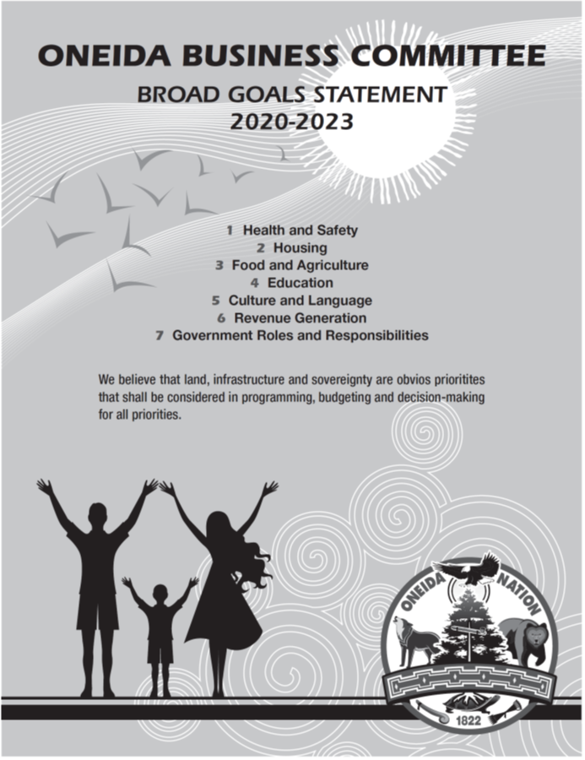The Oneida Business Committee understood entering our term of office that the Nation needed to be nimble in our ability to navigate the changing circumstances on how this disease impacts the community and our members.

With this need in mind, the OBC opted to create broad goals around seven key areas of governance which are:

1. Health & Safety
2. Housing
3. Food & Agriculture
4. Education
5. Culture & Language
6. Revenue Generations, and
7. Government Roles &

Responsibilities

In alignment with these areas, the FY’22 budget was developed with partial intent to ensure the ARPA funds received by the Nation supports long-term recovery and strategic growth.

## Part VII – Reporting and Communications

During the Public Health State of Emergency, the Oneida Business Committee realized that our tribal membership was eager to get back to holding regular General Tribal Council (GTC) meetings and receive important information about the Nation. The Business Committee’s first priority was to ensure that our membership is healthy and stays protected from the COVID-19 virus. Therefore, the Business Committee adopted BC Resolution #12-09-20-C that set forth the reporting requirements during 2020 and 2021.

The COVID-19 Reports for Oneida Nation Members were created to inform the tribal membership about the activities of the Nation during the pandemic. Five updates have been provided thus far and will serve as the 2020 Semi-Annual reports. This sixth COVID-19 Update for Tribal Members along with the Fiscal Year 2020 reports accompanying this report, will serve as the 2021 Annual Report. Additionally, 2021 reporting will be forthcoming in the form of COVID-19 Update for Tribal Members between January 2021 and July 2021. The Business Committee has been exploring the use of technology to hold General Tribal Council meetings while ensuring the meetings are interactive, attended by only tribal members, voting feature-enabled, and ensuring that information continues to remain confidential. As stated previously in this report, the Nation held its first virtual General Tribal Council (GTC) meeting on November 15, 2022. InEvent was the company contracted to use their platform services for the virtual GTC meeting, which came equipped with everything we needed to ensure an interactive experience and confidentiality. Unfortunately, the meeting ended due to the varying levels of connectivity from GTC members who were in attendance. This labored the interaction between the Oneida Business Committee and some GTC members. Since the virtual GTC meeting, the Nation has held five (5) in-person GTC meetings at the Radisson Hotel & Conference Center in 2023.

In 2020, the Ho Chunk Nation utilized multiple platforms for viewing the meeting and voting. However, the meeting was concluded due in part by non-tribal members gaining access into the meeting.

Organizational reporting will continue to occur in the form of quarterly reporting to the Business Committee. You will find the information on the Nation’s website at [www.oneida-nsn.gov](http://www.oneida-nsn.gov)

The Nation also created and has been utilizing other venues to provide information to the community and membership during the COVID-19 pandemic, including;

* Facebook Live Updates - On Tuesdays and Thursdays at 12:00 PM (noon) there are Facebook Live Updates from Business Committee Councilmembers, organizational leadership, and Oneida’s Healthcare professionals.
  + Business Committee Councilmembers and organizational leadership provided updates on major events and information.
  + Healthcare professionals provide community updates on COVID-19 statistics and news.
  + A total of 28 Facebook Live Updates have been broadcasted over 300 FB to date.
  + Approximately 1200 – 1300 view these segments weekly.
* Live Business Committee Meetings - A total of 16 Bi-weekly Oneida Business Committee Meetings have been live broadcasted on the Oneida Nation’s YouTube channel.
* Oneida Nation Call Center is a communication hub that serves as central point of contact for Oneida Nation members who are seeking information about Covid-19 testing and vaccination, programs and services, and governmental processes.
  + Call Center Phone Number: (920) 869-4481
  + Call Center Email: COVID-19@oneidanation.org
* Call Center Overview Analysis-

The Oneida Nation Call Center (formally the Covid-19 Hotline) has tallied approximately 16,690 inbound and outbound calls since October 1st, 2020. That equates to approximately 24 calls per day (16,690 calls/706 business days). There have been a variety of calls received by the Call Center that pertain to Coronavirus Relief Funded (CRF) programs such as the Pandemic Relief Assistance Program (PRAP), Pandemic College Relief Assistance Program, Child Care Development Fund, BIA Covid General Assistance Program, Winter Food Card Program, Covid-19 Testing and Vaccination information, American Rescue Plan Act Federal Relief Funds (ARPA-FRF) funds, Vaccine Incentive program, General Welfare Assistance (GWA) program, Food Assistance program, Virtual GTC Meeting, GTC Prep Community Meetings, GTC Information, and miscellaneous calls requesting to be directed to other internal departments such as Human Resources Department (HRD), Trust Enrollment, Oneida Comprehensive Health, Economic Support Services, Behavioral Health, etc.

Oneida Nation members contacted the Call Center about the Winter Food Program inquiring what qualified as a sufficient form of identification, where to pick up their food card, if they could pick up on behalf of another Tribal member, how many food cards they could pick up at a time etc. Inquiries for the Pandemic College Relief Assistance Program consisted of students requesting status updates on their application, follow-up on what other documents needed to be submitted to be considered for funding through the program, and when they would receive their funding. Calls pertaining to Covid-19 testing and vaccination consisted of members asking about testing availability and the dates and times for upcoming Covid-19 vaccine clinics. Inquiries about ARPA-FRF pertained to how much funding the Oneida Nation received from the Federal government, what formula was used to identify the amount of funding the Oneida Nation was eligible for, details regarding the spending plan created by the OBC, how the ARPA-FRF was being expended, and requests for a spreadsheet of obligations and expenditures for ARPA-FRF. Direct Membership Payment programs such as PRAP, GWA and Food Assistance had inquiries from members asking if their application was successfully submitted, when they would receive their payment, what mailing address or bank account their payment would be delivered to, how much of a payment they were eligible for based on age, and whether the payments were taxable or not. Members also requested assistance with submitting applications and updating their mailing address and direct deposit information for those programs.

The Call Center provided technical assistance to Oneida Nation members that needed help with the Members Only portal, Virtual GTC Meeting, GTC Prep Community Meetings, and Direct Membership Assistance programs such as GWA, Vaccine Incentive, and Food Assistance. Oneida Nation members can contact the Call Center to get assistance with logging onto Members Only, verifying their account information or resetting their password. Furthermore, step-by-step instructions have been created and are available on the Members Only Login page which guide members through the process of verifying their Members Only account, resetting their password, and successfully logging onto the Members Only. Through Members Only, the Call Center assists members with updating their Member Information such as their mailing address, contact (phone number(s) and email address) and direct deposit information. Other key technical services the Call Center has provided is assisting members with submitting applications for the GWA payment program, Vaccine Incentive program, and Food Assistance program. The Call Center served as the central point of contact for information and technical assistance regarding the Virtual GTC meeting and GTC Prep Community Meetings. Members were able to get assistance with registering for both the Virtual GTC and Prep Community meetings and have been able to receive guidance on how to join each respective sets of meetings and how to navigate the virtual platform through InEvent.

Depending on the request, calls led to extensive follow-up with Tribal members and constant communication with internal departments such as Central Accounting, Oneida Trust Enrollments, and Economic Support Services to ensure that Tribal members received their payments via the PRAP, GWA and Food Assistance programs. The Vaccine Incentive also required extensive follow-up with Oneida Nation members and internal departments such as Community Health Services and Digital Technology Services (DTS). Follow-up and communication consisted of confirming that members had successfully submitted an application and their Proof of Vaccination for the Incentive program. Other follow-up assistance consisted of assisting members with getting their payment to them if their payment was delivered to an outdated mailing address or a bank account that had been closed.

As of 2023, the Call Center continues to serve as the central point of contact for tribal member information for the Oneida Nation.

We look forward to closing out 2023 strong; we want to say Yaw^ko for all the support our people have offered to the Nation and to one another. Our prayers continue to be with our families.

**A good mind. A good Heart. A Strong Fire.**