**Volunteers needed for an interview-based study about delivery methods among Native mothers in Brown County**!

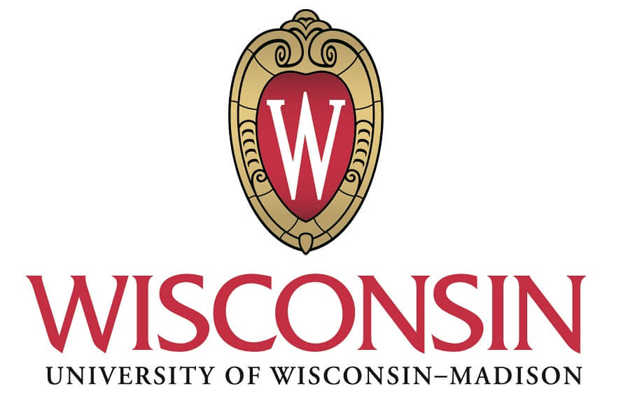

**Have you ever had a C-Section?**

## **What is this study about?**

The Oneida Comprehensive Health Division/Prenatal Care Coordination Program has partnered with a Native medical student at the UW School of Medicine to understand Native moms experiences during pregnancy after having a prior C-Section. This is a community-led project, and so we are looking to hear from Native women in the community to share their voices, stories, and opinions.

## **What do I have to do?**

We will be doing virtual or phone interviews asking questions about your experiences in previous pregnancies and deliveries, such as when they occurred and what type of delivery you had (C-section, vaginal birth, etc.). We will also be asking more specific questions about your experiences with the pregnancies after a C-section delivery. We will not be sharing any identifying information such as your name, address, phone number, nor will we be doing any testing.

## **Why is this important, and what is our goal?**

Some of our previous work has shown that after C-sections, Native mothers in Brown County are more likely to receive another C-section rather than to attempt a Vaginal Birth after Cesarean (VBAC) than non-Native women. Multiple surgeries are associated with greater risks of infection, hemorrhage, and other health risks. We are trying to understand patient experiences during pregnancy or delivery after a C-section to figure out possible reasons for the difference in these delivery method rates. We are looking for ideas about how we can close the disparity gap between racial groups in Brown County.

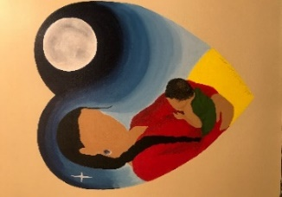

**How do I get involved? Please contact: Megan Murphy-Belcaster** at [mmurphybelca@wisc.edu](mailto:mmurphybelca@wisc.edu) **OR Candi Cornelius** at [ccorne13@oneidanation.org](mailto:ccorne13@oneidanation.org) or **call 920-869-4940**