PUBLIC NOTICE: AGRICULTURAL LAND LEASE FOR BID

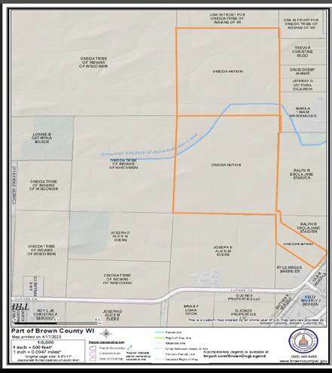Reference Number: 11201904AGS Approximate Acreage: 88.8

Location: 500 Block of S. Overland Drive, Hobart, WI 54115; Parcels HB-17-1; HB-28 & HB-455

Lease Term: 5 years with 5 years option

Minimum Bid: $175.00 per acre (Non-Tribal Members)
$125.00 per acre (Tribal Members)

ALL APPLICATIONS MUST BE TURNED IN NO LATER THAN 4:00 P.M. ON FRIDAY, JUNE 9, 2023. APPLICATIONS WILL NOT BE ACCEPTED AFTER THIS DATE AND TIME. COMPLETED BID APPLICATIONS MUST BE SUBMITTED IN A SEALED SECURITY ENVELOPE LABELED WITH THE REFERENCE NUMBER; UNLABELED ENVELOPES WILL NOT BE ACCEPTED. BID OPENING WILL BE MONDAY, JUNE 12, 2023 AT 10:00 A.M.

Applications are available on our website at: http://land.oneidanation.org

Paper copies of the application can be picked up and dropped off at our office located:

Land Management 470 Airport Drive
Oneida, WI 54115

Applications can be mailed to:

EHSLA Division
P.O. Box 365
Oneida WI 54155-0365
Attn: Mary Jo Nash

METHOD OF DETERMINING WHO WILL BE AWARDED THE LEASE:
- Date and time application is received
- Tribal department or Tribal member will be given priority in the case of a tie
- Following the Agricultural Rule – Distribution of Tribal Agricultural Leases

