Title 1. Government and Finances – Chapter 124
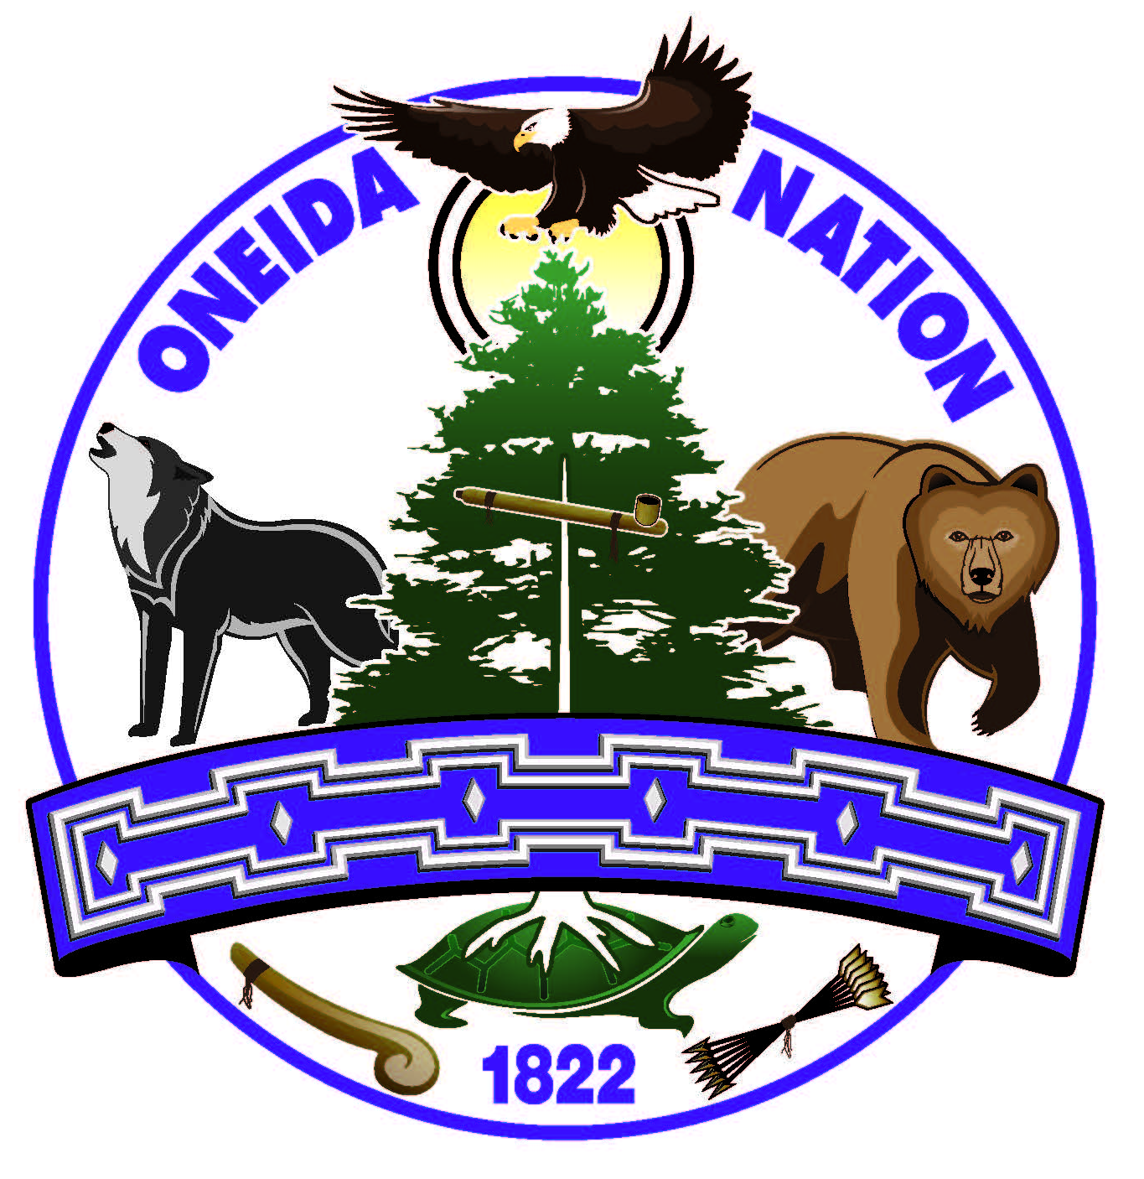
MEMBERSHIP ORDINANCE
Rule #1 –Enrollment Rule

1.1 Purpose and Delegation
1.2 Adoption and Authority
1.3 Definitions
1.4 Maintenance of Confidentiality
1.5 Maintaining Records
1.6 Verification of Authenticating Documents
1.7 Removal of Tribal Roll

1.1. Purpose and Delegation
1.1-1. Purpose. The purpose of this rule is to create enrollment procedures for carrying out the responsibility delegated to the Oneida Trust Enrollment Committee in the Membership Ordinance.
1.1-2. Delegation. The Membership Ordinance delegated the Oneida Trust Enrollment Committee rulemaking authority pursuant to the Administrative Rulemaking law.

1.2. Adoption and Authority
1.2-1. This rule was adopted by the Oneida Trust Enrollment Committee in accordance with the procedures of the Administrative Rulemaking law.
1.2-2. This rule may be amended or repealed pursuant to the procedures set out in the Administrative Rulemaking law.
1.2-3. Should a provision of this rule or the application thereof to any person or circumstances be held as invalid, such invalidity shall not affect other provisions of this rule which are considered to have legal force without the invalid portions.
1.2-4. In the event of a conflict between a provision of this rule and a provision of another rule, internal policy, procedure, or other regulation; the provisions of this rule control.
1.2-5. This rule supersedes all prior rules, regulations, internal policies or other requirements relating to the Membership Ordinance.

1.3. Definitions
1.3-1. This section governs the definitions of words and phrases used within this rule. All words not defined herein are to be used in their ordinary and everyday sense.
(a) “Committee” means the Oneida Trust Enrollment Committee.
(b) “Department” means the Trust Enrollment Department.
(c) “Judiciary” means the judicial system responsible for applying the laws of the Oneida Nation. The three branches, as identified in resolutions BC-05-08-13-A and GTC 01-07-13-B are the Family Court, Trial Court and Court of Appeals.
(d) “Minor” means anyone who has not yet attained the age of eighteen (18).
(e) “Nation” means the Oneida Nation.

1.4. Maintenance of Confidentiality
1.4-1. The Department and Committee shall not make available for inspection or disclose the contents of any record kept or information received regarding enrollment except to designated enrollment employees, as provided in this section, or by order of the Judiciary or another court of competent jurisdiction.
(a) The Department and Committee are not prohibited from making available for inspection or disclosing the contents of a record upon the request of the person or the guardian of the person who is the subject of the record or, if the subject of the record is a minor, upon the request of the parent, guardian, or legal custodian of the minor.
(b) The Department and Committee are not prohibited from making available for inspection or disclosing the contents of a record upon the written permission of the person or the guardian of the person who is the subject of the record or, if the subject of the record is a minor, upon the written permission of the parent, guardian, or legal custodian of the minor, unless the Department or Committee determines that inspection of the record by the person named in the permission would result in imminent danger to anyone.
(c) The Department and Committee are not prohibited from making available for inspection or disclosing the contents of a record to a Tribal enrollment department, a social welfare agency, a law enforcement agency, a health care provider, a public or private school, or other business unit of the Nation if the Department or Committee determines that the exchange of information is necessary to satisfy a particular purpose or carry out a function. The exchange shall be limited to the minimum necessary to accomplish the intended purpose.

1.5. Maintaining Records
1.5-1. The Department and Committee shall store records in a safe place located within the Oneida Tribal Enrollment Office. Records shall be updated and organized in a manner that allows for thoroughness and accuracy of records, as well as efficient retrieval.
1.5-2. The Department and Committee shall ensure that all duplicate records in their possession shall be stored in a safe place.

1.6. Verification of Authenticating Documents
1.6-1. The Department and Committee shall confirm through the evaluation of original signatures, stamp prints, and seals, that all documents submitted are authentic.

1.7. Removal of Tribal Roll

1.7-1. Removal of the official Tribal roll from its designated Tribal office must be approved by the Committee prior to such removal. An appropropriate instance for removal shall include, but not be limited to voter registration.

End.

Original effective date: 01-10-2018

