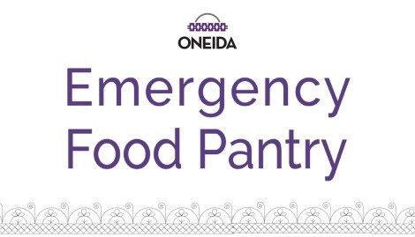

N7372 Water Circle Place, Oneida WI 54155
920-869-6165
6/12/19
Welcome to Oneida Emergency Food Pantry (OEFP)!
INTERVIEW HOURS | FOOD DISTRIBUTION HOURS
Tuesday 11:00AM – 1PM* | Tuesday 11:00AM – 1:30AM*
Thursday 11:00AM – 1PM* | Thursday 11:00AM – 1:30PM*
*Please arrive at least 10 minutes in advance of the deadline to ensure that you are served the same day. | *Please arrive at least 10 minutes in advance of the deadline to ensure that you are served the same day.
At every interview, you are required to bring all of the following items: Plus, the reasoning of why you are utilizing the pantry, your circumstance, or emergency.
Member Household Information
- Tribal ID of at least one enrolled member  - Enrollment numbers of Oneida enrolled | - Dates of Birth all household members
Proof of current address. Acceptable proof of current address* includes any of the following:
- Any bill  - Any Mail | - Tribal ID  - State ID’s
Proof of ALL household income. This includes the following:
- Wages from a job | - Social Security/SSI/SSD
- Child, Spousal, Family Support or Alimony
- Unemployment or Worker’s Compensation | - Tribal income
If you have never been a client of OEFP and you do not have all the information needed, you may wait to see an interviewer who will try to help you. If you are renewing or have been a client in the past, an interviewer cannot help you unless you have all the required documents above.

Reminder: Income or proof of address does not disqualify from using our services. Only used for recording purposes. Proof of job income, fixed income, disability, or SSI will give you longer certification periods.

