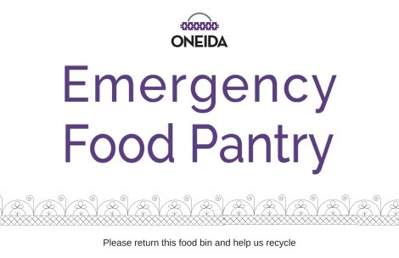

Volunteer Code of Conduct

Oneida Emergency Food Pantry agrees to accept the services of the volunteer and to commit to the following:

- Assign the volunteer a position that best matches the volunteer’s skills and interests.
- Provide information, orientation and on-going training for the volunteer to be able to meet the responsibilities of the position.
- Respect the skills, dignity and individual needs of the volunteer, and do our best to accommodate those individual requirements.
- Provide supervisory assistance and support to the volunteer and feedback on performance.
- Be receptive to any volunteer concerns and suggestions regarding ways to carry out the mission of Oneida Emergency Food Pantry.

I, ________________________________, agree to serve as a volunteer and commit to the following:

- Read, understand and adhere to the contents and expectations of the Oneida Emergency Food Pantry “Code of Conduct”.
- Perform assigned duties to the best of my ability without monetary or in-kind compensation.
- Attend Volunteer orientation and any required on-going trainings.
- Create a safe environment by treating all clients, volunteers and staff with dignity and respect.
- Keep all knowledge of client identity and client information confidential.
- Refrain from using cell phones during client assistance.
- Adhere to a professional relationship with clients at all times.
- Use of drugs or alcohol or being under the influence of drugs or alcohol while volunteering is prohibited.
- Food is not to be taken by volunteers unless specially permitted by food pantry manager or staff member at the end of a volunteer shift. Food must come from donated sources only.
- Food should not be eaten in front of clients.
- Meet time and duty commitments, or provide adequate notice to STAFF, so that alternative arrangements can be made.
- Communicate with STAFF any concerns and questions regarding volunteer responsibilities and be willing to accept guidance and directives from the staff.
- Report any knowledge of inappropriate activity by any client, staff or volunteer, which is against our policy or law.
- Adhere to Basic Food handling safety (Gloves, Handwashing, Hair nets, Cross Contamination, Etc.)

My signature on this document acknowledges that I understand and will abide by this agreement and all pantry rules, policies and procedures.

______________________________ ____________________________________

Volunteer Manager, OEFP

______________________________ ____________________________________
Date Date

